|  |
| --- |
|  |
| Knowledge Document |
| (Runbook) |
| App ID: Ecomm Contentful CMS - APP Dev |
| |  |  | | --- | --- | | Tower | Ecommerce | | Track | **Ecommerce – App Dev** | | Sub-Track | **Contentful CMS – App Dev** | |
|  |
|  |

**Revision History**

|  |  |  |  |
| --- | --- | --- | --- |
| Version No. | Date | Prepared/ Modified by | Key Changes |
| Draft | 12-Jul-2024 | Ramana, Akhila, Anuj |  |
|  |  |  |  |

**Glossary**

| Abbreviation | Description |
| --- | --- |
| KT | Knowledge Transfer |
| CMS | Content Management System |
| KDP | Keurig Dr Pepper |
| App Dev | Application Development |

**Table of Contents**

1. Introduction 1

1.1. Purpose of Document 1

1.2. Scope of Document 1

1.3. Audience 1

2. Business Process Coverage and Functional Overview 2

2.1. Application Business Context 2

2.2. Application Functional Overview 2

3. Technical Overview 3

3.1. High Level Technical Architecture and Interfaces Understanding 4

4. Detailed Functionality and Customizations 7

4.1. Detailed Functionality 7

4.2. Application Spaces and Environments Details 8

4.3. Content models and Content types 8

4.4. Integrations, Apps, locales 11

5. Important content Models and Landing pages 15

5.1. Content Hub Landing page (Primary landing page) 15

5.2. Sustainability Landing page – Content Entry 17

5.3. PDP Landing Page – Content Entry 19

5.4. Recipe Page 21

5.5. Mobile App Home Page 24

# Introduction

* 1. Purpose of Document

This document provides the functional and technical overview of “Ecomm Contentful CMS - APP Dev*”* along with operational information that would be required to support the application on a day-to-day basis. Objective for preparing this document is to capture comprehensive knowledge about “Ecomm Contentful CMS - APP Dev*”* in single place. Thus, reducing effort of readers to refer multiple documents

* 1. Scope of Document

This document covers the following for *<<* Ecomm Contentful CMS - APP Dev *>>* ─

1. Business/Functional Overview
2. Technical Overview
3. Detailed Functionality, Technical Architecture, Interfaces & Customizations
4. Data Model, Data Flows & Reporting
5. Security, Batch Jobs and Other Non-ticketing Activities (including business events e.g., PEC/YEC)
6. End User Support
7. Support Process
8. AD & Testing Services
   1. Audience

This document could be referred by following ─

1. Project Manager
2. Business Analyst
3. Developers
4. Testers
5. Support Personnel

# Business Process Coverage and Functional Overview

* 1. Application Business Context
* Understanding of overall business and domain overview and application's business context.
  + Keurig Dr Pepper is a leading beverage company in North America, with a portfolio of more than 125 owned, licensed and partners brands and powerful distribution capabilities to provide a beverage for every need, anytime, anywhere.
  + The company’s product portfolio includes coffees, carbonated soft drinks, ready-to-drink tea, water, juices, and juice drinks and mixers. KDP markets its products under Dr Pepper, Snapple, Keurig, Green Mountain, Donut Shop, Van Houtte, REVV, and Mott's brand names
* Understanding of business Sites & Apps Functional Requirements.
  + There are two B2C websites such as Keurig.com for NA and Keurig.ca for Canada
  + There are Mobile Apps with subset of Sites functionalities
  + Sites and Mobile Apps share common content for articles and Recipes from Contentful
* Understanding of Contentful application business processes and sub-processes
  + Contentful is a headless Content Management System (CMS) that allows business users/ content authors to create, manage and distribute/deliver content to any platform/channel such as websites, mobile apps, or any connected device that displays content.
* Understanding of Content Delivery to Mobile Apps and Ecomm Channel.
  + Keurig.com and Keuring.ca Sites consume non-commerce content such as articles, recipes from Contentful
  + Mobile Apps consume non-commerce content such as articles, recipes from Contentful
  + Keurig.ca has multi-linguals with English and Canadian French with Fallback as English
  + Content is consumed by channels using Content delivery APIs
* Understanding of Integration for hero lids & pod file data ingestion and Integration with IoT cloud for appliance capability file.
  1. Application Functional Overview
* Composable content platform, with API first approach, to meet current and future digital needs.
* Information architecture driven taxonomy for increased findability and organized content.
* GraphQL enabled services for simplified and faster response formats.
* Gatsby integrated architecture for SEO and performance optimized website implementation.
* Apps such as Compose, Launch, Workflow apps are leveraged to deliver pages, associated content and variations.
* Multi-lingual enabled flexible solution for delivering the website content in English language and adaptable to on-board new languages as the platform scales.
* Reusable content types and intuitive content design to enable marketing teams / staff for faster content publishing and greater content governance through implemented publishing workflows.
* Solution is future-ready, scalable, secure, high performant and operationally efficient in design
* These applications utilize different APIs provided by Contentful:
* Delivery API: Fetches published content to be displayed in the applications.
* Preview API: Retrieves draft content for previewing changes before they go live.
* Image API: Optimizes and serves images for different devices and resolutions.

Structured flow in Fig:2.2 illustrates how content is managed, integrated, and delivered across various platforms and applications using Contentful's robust API infrastructure.

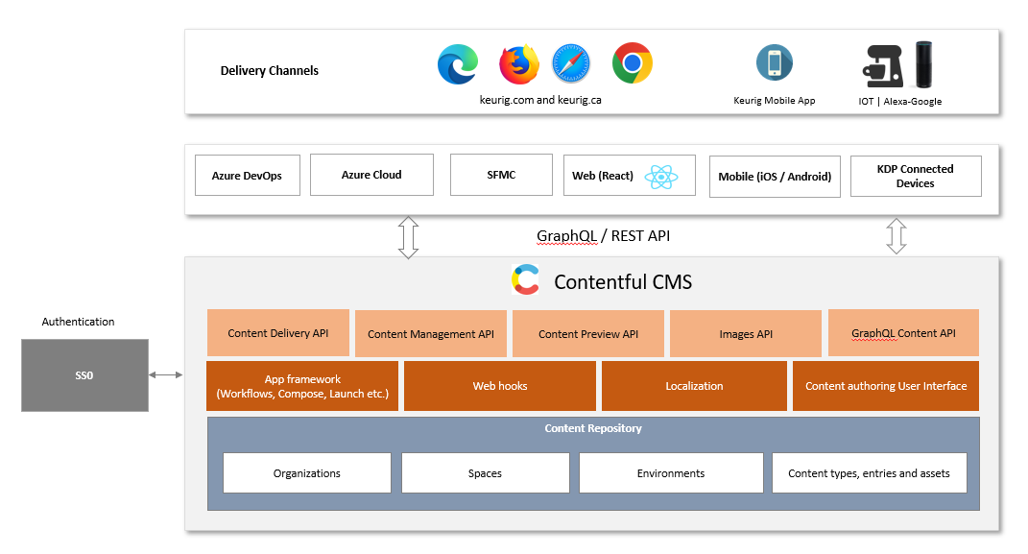

Fig: 2.2

# Technical Overview

In Organization “Keurig Dr Pepper”, there are two spaces created i.e. KCBU and KCOM and each of these spaces has multiple environments to host content types and entries to deliver them to ecommerce channels and connected devices using graph QL API’s. Content is delivered to Azure Cloud and SFMC (Sales Force Marketing Cloud) using webhooks.

The details of 2 spaces created in Contentful Organization:

* KCBU (Keurig Connected Business Unit) Space:
  + Consists of various content categories such as Mobile App Configuration Content, Pod Files, Recipes, Mobile App Pages, Lucky Brew Campaign, Brand Logos, Variety Logos, AFH brewer beverages, recipes etc.
  + Delivers content to Sites (Keurig.com, Keurig.ca) and Mobile Apps using GraphQL APIs
  + Delivers content to Azure Cloud for POD metadata updates using webhook
  + Delivers content to SFMC for Lucky brew campaign updates using webhook
  + Azure DevOps deploys POD files and Hero lids files to Contentful with release pipeline using Rest API.
* KCOM (Keurig.com) Space:
  + Consists of various content categories such as Content hub Landing Pages, Recipes Landing Page, Lifestyle and Support Articles, Sustainability Landing Page, K Rounds, Content Next Gen brewer pops.
  + Delivers content to Sites (Keurig.com, Keurig.ca) using GraphQL APIs

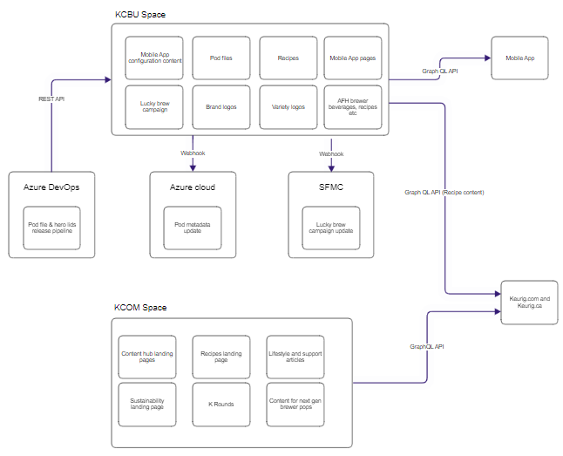

Fig: 3.0

* 1. High Level Technical Architecture and Interfaces Understanding
* **Understanding of integration architecture, architecture roadmap**.

**Flow Diagram for landing page (Sustainability):**

* Hybris Server (SSR):
* Upon page load, the browser sends a request to the Next.js frontend, which in turn makes a Page API call to the Hybris server. The Hybris server processes this request and sends back the Page API response to the Next.js frontend, which then renders the initial Page DOM on the browser.
* Contentful (CSR):
* Once the initial page is loaded, the browser triggers the CMS component load, initiating a React (frontend) request.
* The React frontend makes a GraphQL query to the Contentful API, using Hybris siteConfig obtained from the Page API.
* The Contentful API processes the request and returns the Contentful API response to the React frontend.
* The React frontend uses the Contentful API response to render the CMS components, which are then displayed on the browser.

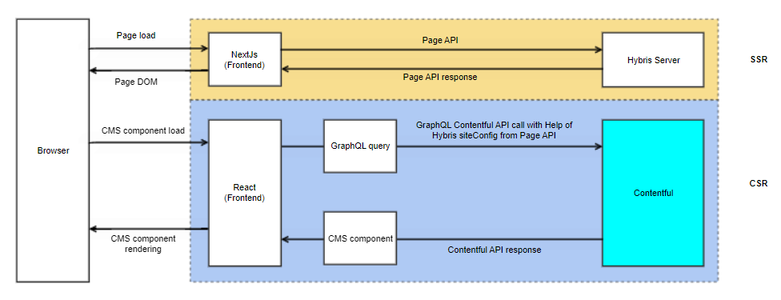

Fig:3.1.1

**Flow Diagram for Smart Family pages:**

To describe the additional details in the flow diagram Fig 3.1.2 compared to the Fig 3.1.1, here are the extra points:

* Page Scroll and Lazy Loading (CSR):
* Upon page scroll, the browser triggers a new React (frontend) request to load additional CMS components.
* React frontend makes another GraphQL query to the Contentful API, using Hybris siteConfig obtained from the Page API.
* The Contentful API processes this request and sends back a Contentful API response.
* The CMS components (below the fold) are rendered in a lazy-load manner, meaning they load only when needed as the user scrolls, optimizing performance and reducing initial load time.

Fig: 3.1.2 highlight the dynamic loading of CMS components based on user interaction, enhancing the efficiency and user experience of the web application.

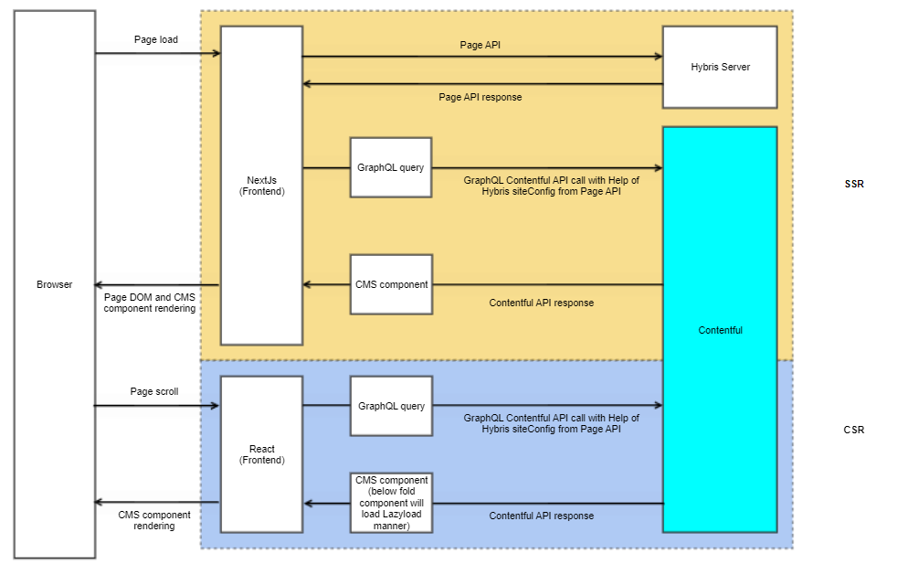

Fig:3.1.2

*Note: GraphQL allows developers to fetch, update, and manage content programmatically, enabling integration with various applications and platforms for both KCOM and KCBU spaces. The GraphQL API provides a more efficient way to query and manipulate content compared to traditional RESTful APIs, allowing clients to request exactly the data they need in a single request.*

* **High level understanding of application interface and inter-connected applications.**
* Space(KCBU): Shows the detail of the current active space in which you are currently editing.
* Environment(UAT): Shows the name of the environment under selected space.
* Home: After logging into the web app, the "Home" tab for your organization is displayed. On this tab, you can find and access all the content for your project.
* Content Model: defines the structure and organization of your content in a space.
* Content: The content tab is where you can find the master list of all content entries in your space.
* Media: Consists of all the assets and media files
* Apps: Custom applications can be installed and used.
* Settings: Account details, customization, permissions, Locales, Webhooks, Tags, Environment Settings and Space Settings etc. are managed here.

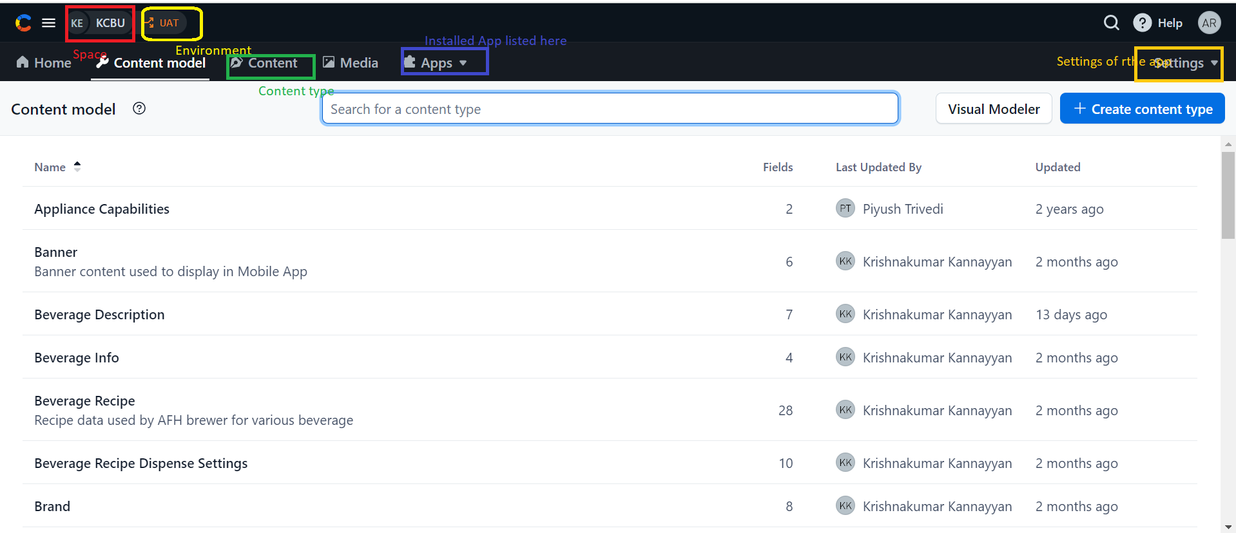

Fig: 3.1.3

# Detailed Functionality and Customizations

* 1. Detailed Functionality

Contentful is a headless Content Management System that allows users to create, manage and deliver the content to different channels such as websites, mobile apps, or any other device that displays content.

The salient features of Contentful CMS:

* Provides a flexible platform for managing content centrally and delivering it across various channels (websites, mobile apps, IoT devices) through GraphQL APIs.
* To design and manage content models as templates for content entries
* To organize and manage content within spaces and environments.
* To define and configure content types and fields.
* Enables teams to unify content in a single hub, structure it for use in any digital channel, and
* Integrates with hundreds of other tools through open APIs and an app framework.
* Decoupled architecture and agile workflows to reduce time to market and increase ROI by extending the value of existing investments
* RESTful & GraphQL APIs with Global CDNs
* Dedicated API endpoints for writing, previewing, and delivering content
* Language and framework agnostic with specific SDKs
* Powerful app framework with open-source editors and design system
* Fully customizable content structure and UI to manage it
* Scheduled publishing, teams, tasks & comments
* Localization with fallbacks







* 1. Application Spaces and Environments Details

**Topics to be covered based on KT provided by incumbent team. (Mark "Not Applicable" if no KT provided on the area)**

Contentful space: Space is where all the content is created with Contentful. It’s your place to keep all the content related to a project. Spaces are where we interact with content for particular goals.

Content is organized and managed within spaces and environments. Spaces are containers for content. Environments within spaces allow for staging, testing, and production workflows, enabling safe content updates and changes without affecting the live content.

An **environment** in Contentful is used to manage different stages of content development and deployment. Environments allow you to create copies of your space's content, enabling safe development, testing, and production workflows. Each space can have multiple environments.

* KCOM Space: used to deliver content to websites (keurig.com, keurig.ca), It has all the content related to primary content hub, PDP
* KCBU Space: used to deliver content to websites (keurig.com, keurig.ca) and mobile app where in the user can see the keurig perks and Mobile app also has Lucky brewers, Brand logos, Variety logos

**List of Environments within KCBU Space:**

* DEV
* REG
* UAT

**Environments within KCOM Space:**

* Content-hub-master-06212024
* Content-hub-nonprod
* Smart-pdp-nonprod
* Smart-pdp-nonprod-06212024
* Smart-pdp-nonprod2
  1. Content models and Content types

**Topics to be covered based on KT provided by incumbent team. (Mark "Not Applicable" if no KT provided on the area)**

A **content model** in Contentful defines the structure of content by specifying the various content types and their relationships.

Each content type represents a specific kind of content, such as an Article, blog post, author profile, Recipe, product, or landing page. A content type is defined by a set of fields describing its structure and characteristics.

Below is the table with number of content types in each environment and space:

|  |  |  |
| --- | --- | --- |
| **Space** | **Environment** | **# Content Types** |
| KCBU | REG | 36 |
| UAT | 35 |
| DEV | 32 |
| KCOM | Content-hub-master-06212024 | 29 |
| Content-hub-nonprod | 29 |
| Smart-pdp-nonprod | 46 |
| Smart-pdp-nonprod-06212024 | 46 |
| Smart-pdp-nonprod2 | 46 |

**Notes:**

* The environments Content-hub-master-06212024 and content-hub-nonprod consists of same content types
* The environments Smart-pdp-nonprod, Smart-pdp-nonprod and Smart-pdp-nonprod2 consists of same content types
* There are many content types, but the major one is the article.

**Blog Article:**

* It is the structured content with below fields:
  + Title,
  + Published date,
  + Author,
  + Hero image,
  + Thumbnail image,
  + Abstract and
  + Body. We can embed other entries or assets within the body.
* There is a feature product section embedded within the article. It has links to the real product pages as reference fields.

**Featured Products (Screen from Keurig.com):**

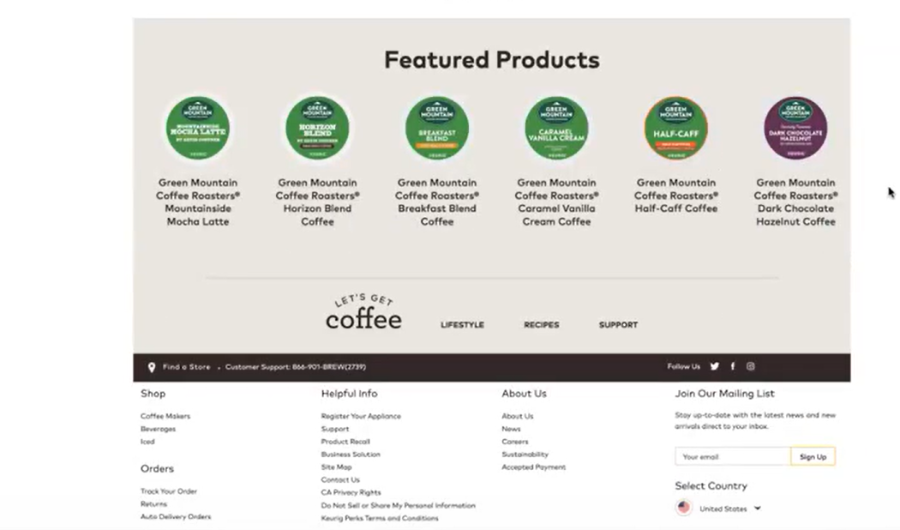  
**Fig:3.1.4: Featured Products**

**Featured Products – Content Model:**

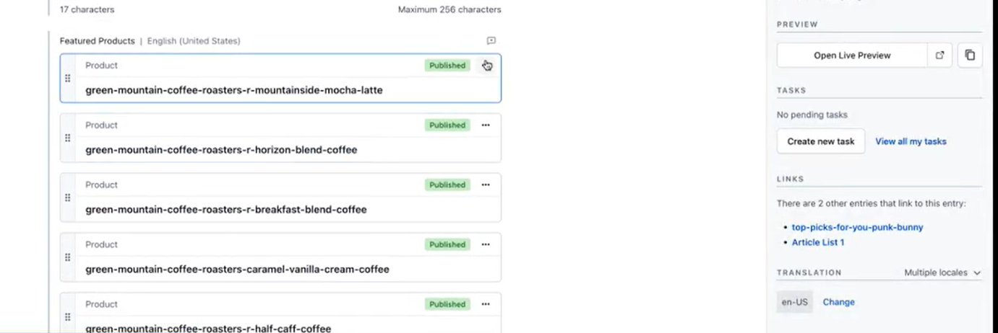

**Fig:3.1.5: Featured Products**

**Featured Products – Content Entry:**

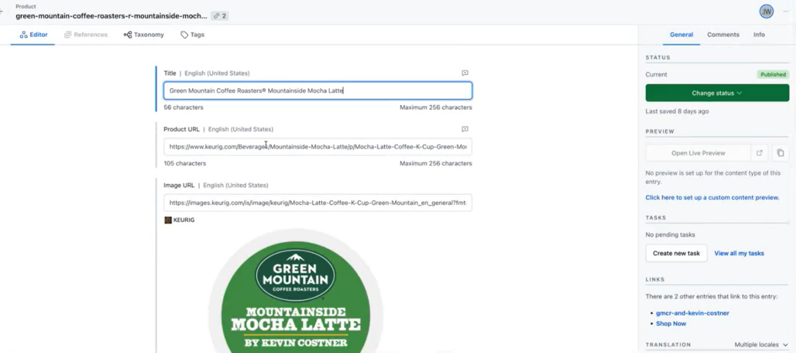

**Fig:3.1.6: Featured Products**

**Article list:**

* These are the article lists inserted within the article as another entry.
* Each article (ex: feature article) is the reference link to another article. They can also refer to external article outside keurig.com with fully qualified URL.

**Hub Home Page (Content Entry)**

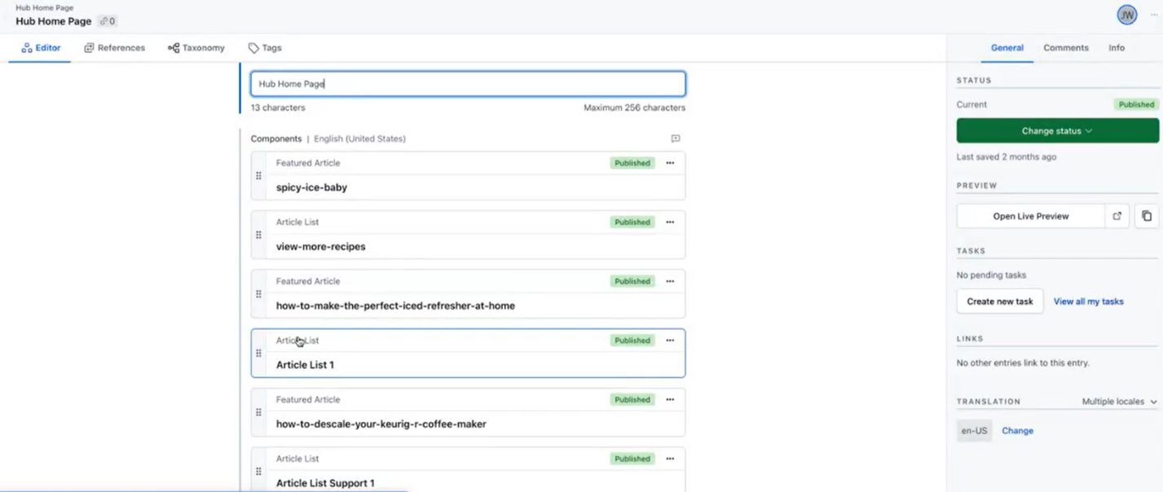

**Fig:3.1.7: Hub Home Page (Content Entry)**

**Featured Article (Content Entry)**

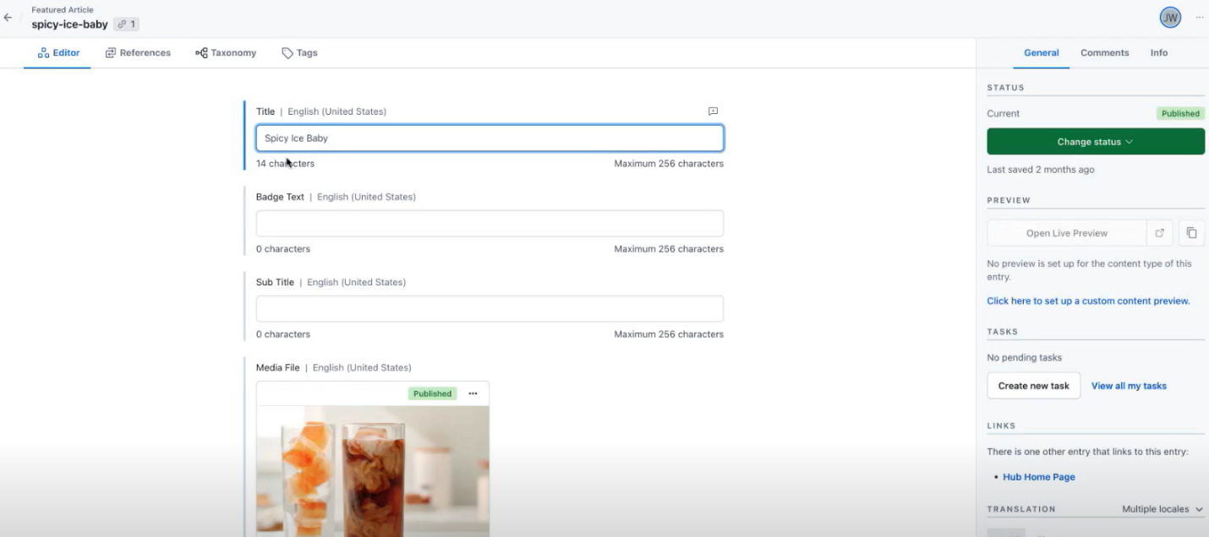

**Fig:3.1.8: Featured Article (Content Entry)**

* 1. Integrations, Apps, locales

**Topics to be covered based on KT provided by incumbent team. (Mark "Not Applicable" if no KT provided on the area)**

* Understand the level of customizations done on the base product and its details
* Any other important area covered as part of KT

**Integrations under KCBU space:**

* **Webhooks:** Webhooks are used within our application to automate specific tasks by sending HTTP requests to other services whenever there occur any changes to the content.

*(Note: We can see webhooks under master-2022-01-14 environment of KCBU space)*

There are multiple webhooks under this space:

* **IoTCloud Webhook**: Publishes the content to the Azure Cloud
* **SFMC Webhook**: Publishes the content for email Campaigns and Inbox messages. When a campaign is published from Contentful, it will push the content to the end point. There are filters for example Environment ID equals “REG” and Content Type = “LuckyBrew” to route the traffic to “REG” environment.

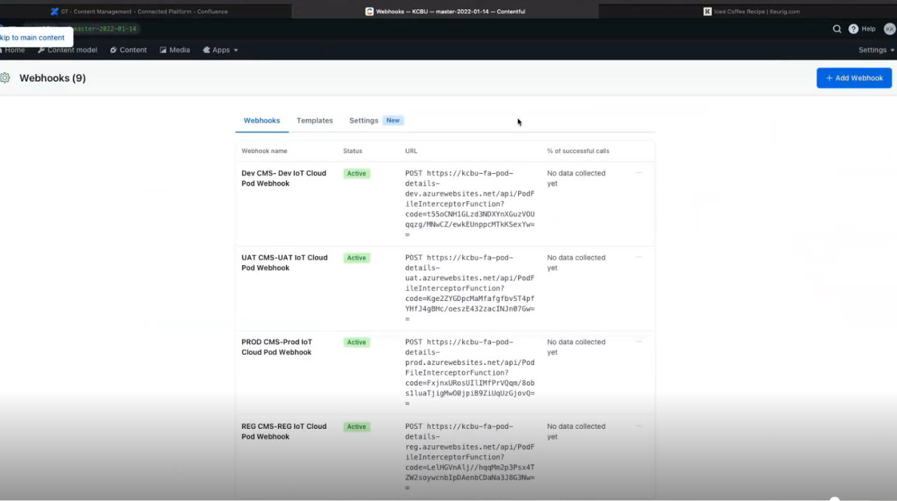

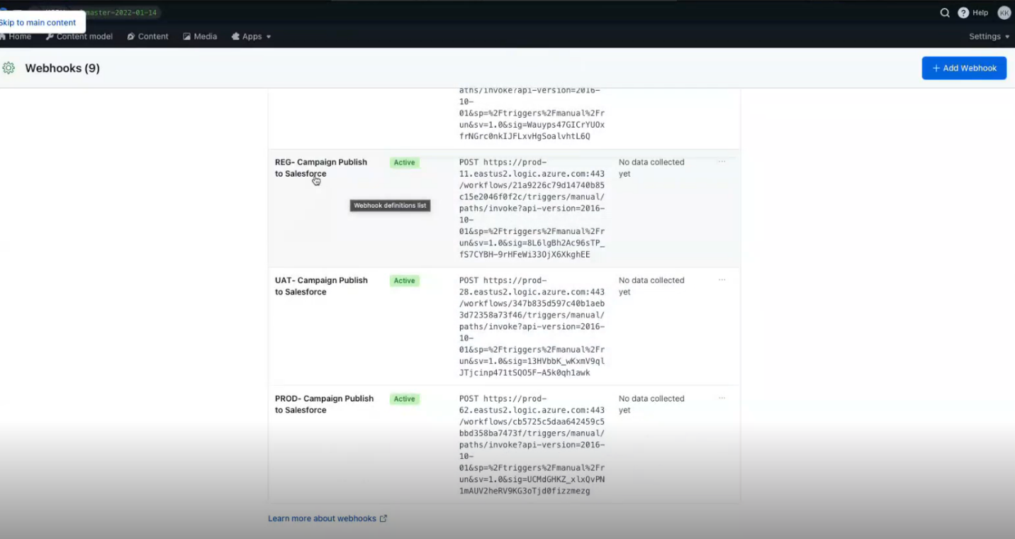

* **Integration to Azure DevOps using REST API**: POD files come from Neuron, load the data from BLOB storage. Azure DevOps release pipeline ingest POD file and hero Lids into content.
* **Integration to Azure Cloud for POD metadata update using Webhook:** Whenever a POD file with content is ingested into Contentful and published, the content would be intercepted into Azure cloud using Webhook.
* **Integration to SFMC for Lucky brew content update using Webhook**: The required content for campaigns is authored in Contentful and is sent to SFMC using webhooks to use that content for e-mail push notifications and inbox messages to the target users. The campaigning timeframes/dates and triggering would be done in SFMC
* **Integration to Mobile App using GraphQL API**: GraphQL pulls the data based on filter OOTB criteria from Contentful. GrapgQL API provides data to Mobile App. REST API is not being used as it requires multiple API calls for each content. With GraphQL, multiple content can be combined. For example, the mobile app requires recipe data and hero lids. GraphQL fetches the combined content in one call.
* **Integration to Keurig.com and Keurig.ca using GraphQL API**: The same recipe content used for Mobile App would be consumed by sites: Keurig.com and Keurig.ca using GraphQL APIs

**Integrations under KCOM space:**

* **Integration to Keurig.com and Keurig.ca using GraphQL API**: The same recipe content used for Mobile App would be consumed by sites: Keurig.com and Keurig.ca using GraphQL APIs

**Apps under KCOM space:**

* **Workflows:** Workflows are implemented for content publishing and un-publishing with defined multiple levels of approvals. In our application, basic workflows are implemented by creating a new task and assign the task to a group, or a team of users and the user gets the automated link from the contentful and he/she can review the content, either approve or reject.

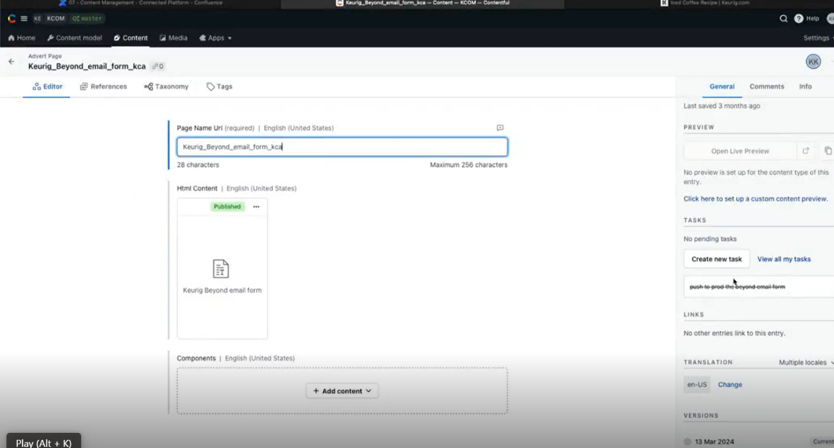*(Here we can see create new task, and assign the task to the team, this is how we create a workflow)*

* **Compose:** Compose is not being used much within our application
* **Launch:** Launch is enabled but not being used much

**Multi-Lingual Requirements**:

* Multi-Lingual is enabled for Keurig.ca site to support English and Canadian French
* Translations are done by Canadian team through manual entry and there is no translation platform for auto-translation
* Below languages are enabled:
  + English (en-US)
  + English (Canada) (en-CA)
  + French (fr)
  + French (Canada) (fr-CA)
  + Spanish (United States) (es-US)
* Fallback is enabled for the below:
  + English (en-US) for English (Canada) (en-CA)
  + English (Canada) (en-CA) for French (Canada) (fr-CA)
  + English (en-US) for Spanish (United States) (es-US)
* Keurig.com doesn’t have locales, it has only English
* Keurig.ca has locales with Canadian English and Canadian French
* For Brewers, there is US Spanish and US French
* App uses the appropriate Locale based on User’s preference

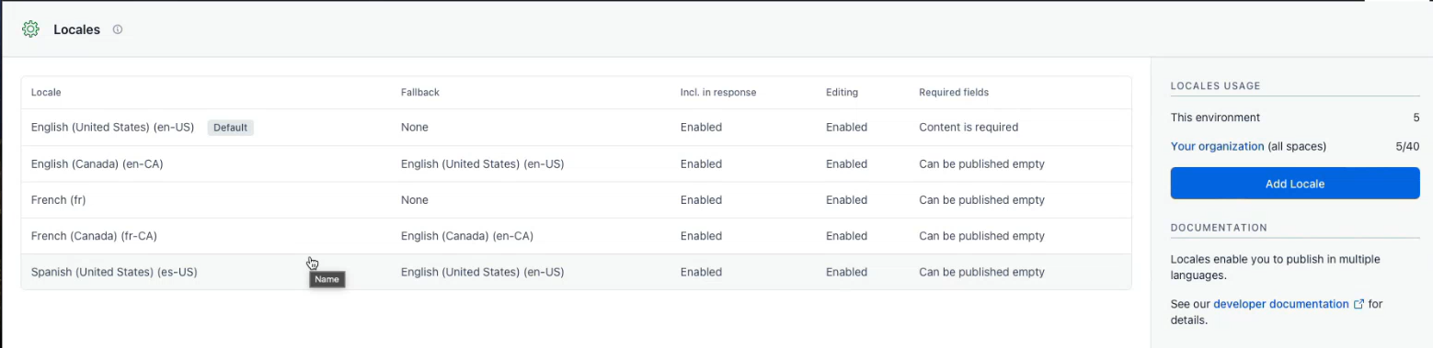

# Important content Models and Landing pages

**Below are the some of the important Content Models/Categories in KCBU Space:**

* **Mobile App Configuration Content**: All the configuration content required for the mobile app
* **Pod Files**: These files are received from Neuron and consists of part related data such as Brand, Variery, Part ID. The Coffee profile such as medium roast, dark roast, iced tea, flavoured tea etc.
* **Recipes**: Same Recipes in mobile app as KCOM has
* **Mobile App Pages**: There are many landing pages required by mobile app including home page, Keurig perks page, Lucky brew page
* **Landing Pages**:
* **Lucky Brew Campaign**: It is not yet enabled in production but implemented in development
* **Brand Logos**: for given Pod. Breakfast blend, Hero lids from mobile app
* **Variety Logos**: for given Pod
* **AFH Brewer beverages, recipes etc**.: AFH Brewer stands for Away from Home Brewer and customers are B2B. There are connectivity enabled brewers called 4500 Brewer with big screen with multiple beverage types: Cappuccino, Americano, Latte etc.

**Below are the some of the important Content Models/Categories in KCOM Space:**

* Content hub Landing Pages
* Recipes Landing Page
* Lifestyle and Support Articles
* Sustainability Landing Page
* K Rounds
* Content Next Gen brewer pops
  1. Content Hub Landing page (Primary landing page)
* In Keurig.com website, Contentful is primarily being used for project contenthub for recipes and more in the navigation.
* Under recipes and more navigation all content including assets comes from Contentful.
* Header and Footer are part of Global template from SAP Hybris
* These pages are developed using ReactJS with Client-Side Rendering which means JavaScript is compiled on the React Server side and sent to Browser
* The Landing page is composition of Recipes and Articles
* The core of content hub is the Articles and they are sort of semi-structured with defined content types and attributes such as title, date, author, image and RTE (WYSIWYG).
* The content team can make use of the RTE to insert other content types, list of other articles, list of other products, images or videos within RTE.
* In Recipes & More page, there are 3 sections:
  + Lifestyle
  + Recipes
  + Support

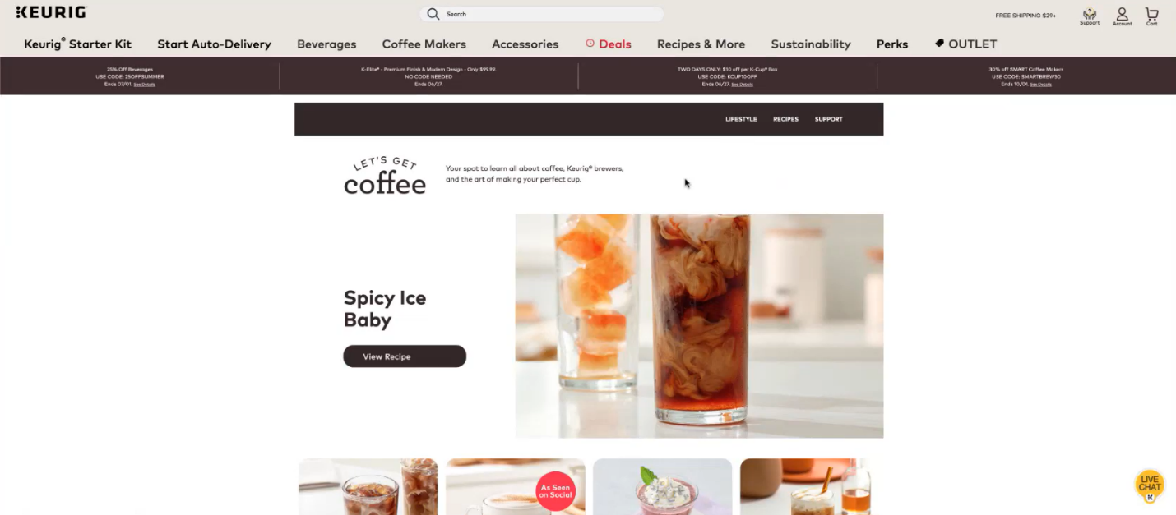

**Fig:3.1.8: Recipes & More Landing Page**

* Lifestyle and support are listing pages with banner and text at the top. These listing pages are not editable and these are listed in descending order of date.
* Recipes page: Another major section and the content source is Contentful in space KCBU. The page displays a list of all the recipes.
* The assets are placed in Contentful and Adobe DAM. There is a restriction to place images in Contentful with size less than 2MB. Especially the Larger assets/ images and videos comes from Adobe DAM as they take higher bandwidth for processing and streaming.
* URL for assets in Contentful starts with: images.cfassets…
* URL for Assets in Adobe DAM starts with: images.keurig.com

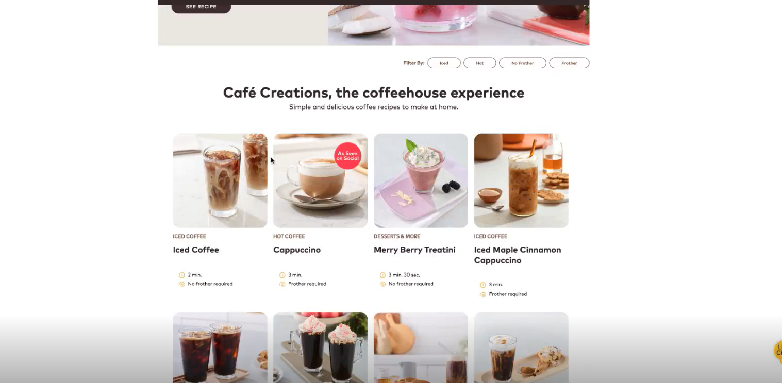

**Fig:3.1.9: Recipes Landing Page**



**Fig:3.1.10: Content Hub Home Landing Page – Content Entry**

* 1. Sustainability Landing page – Content Entry

This is special landing page; outside of articles and recipes and still comes under the hub.

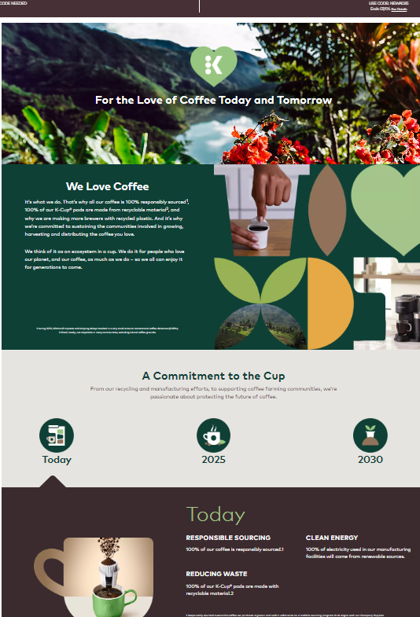

**Fig:3.1.11: Sustainability Landing Page**

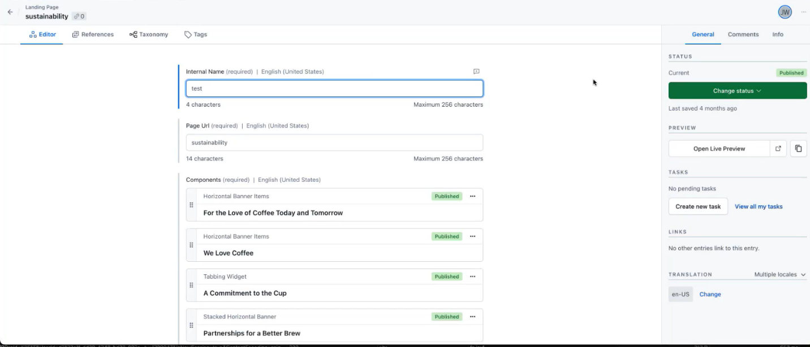

**Fig:3.1.12: Sustainability Landing Page – Content Entry**

* 1. PDP Landing Page – Content Entry
* There are PDP pages with core commerce features. The content for these pages come from Contentful.
* PDPs are mainly targeted for existing & new brewers, and IoT enabled Smart brewers.
* Implemented CSR to fetch content by enabling lazy loading. Means all the sections of the page is not loaded in one go. As user scrolls down the page, content would be loaded from Contentful using Contentful APIs.
* Naming Conventions: For Content Type and entries, naming conventions are used as same being used in commerce site to maintain consistency.
* Under ***master > smart-pdp-dev*** Environment under KCOM, we have PDP Page- this is the primary content type that is being used
* All the heavy assets such as large size images and videos come from Adobe DAM - Scene7
* Assets URL in Contentful starts with: images.ctfassets.net
* Assets URL from Adobe DAM starts with: images.keurig.com

**Caching Images:**

* In Home Page: All the images are hosted in SAP Hybris under Medias
* In Product Pages: All the base images of products are hosted in SAP Hybris. Image sets and everything are hosted in Adobe Scene7 backed by Akamai CDN. Hence these images are cached and served quickly.
* The images hosted in Hybris also get cached in Akamai
* The Image Manager (Image management service) from Akamai transforms the image and gives the image with reduced size and right type.

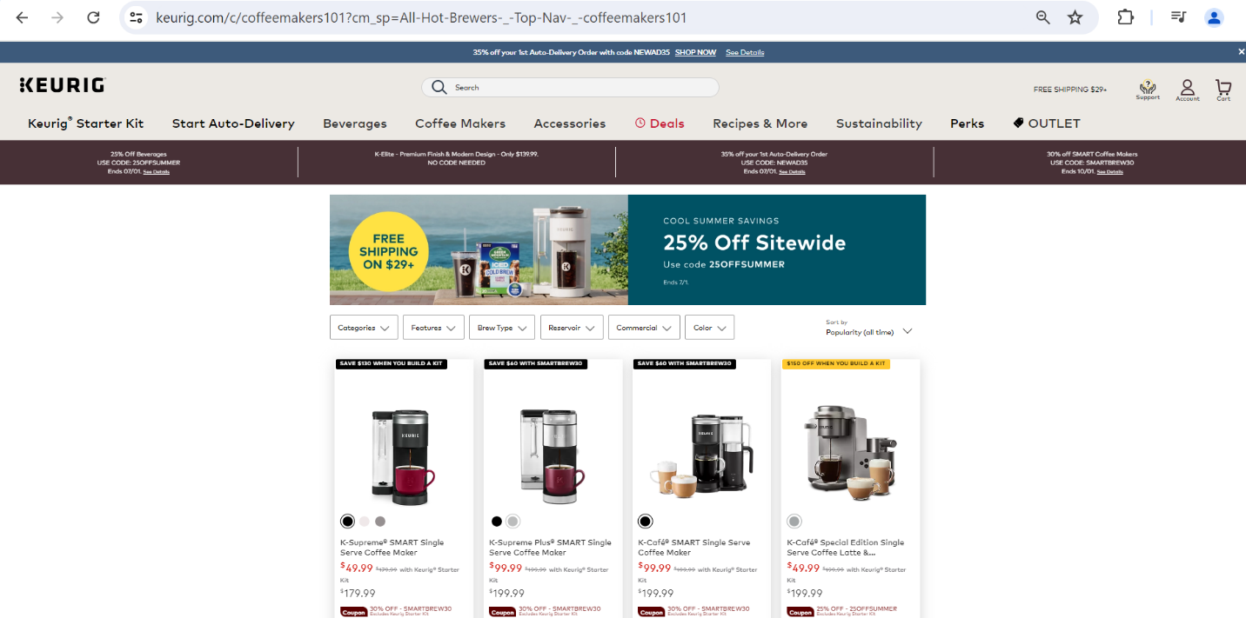

**Fig:3.1.13: PDP Landing Page**

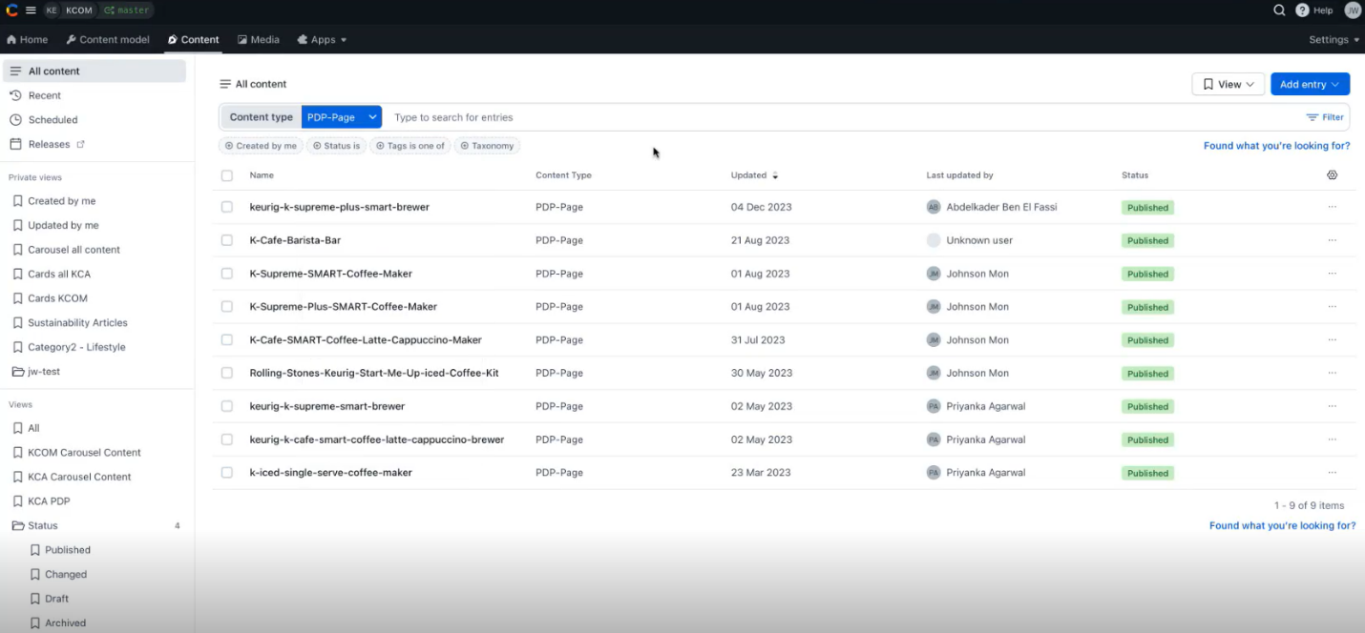

**Fig:3.1.14: PDP Landing Page – Content Type**

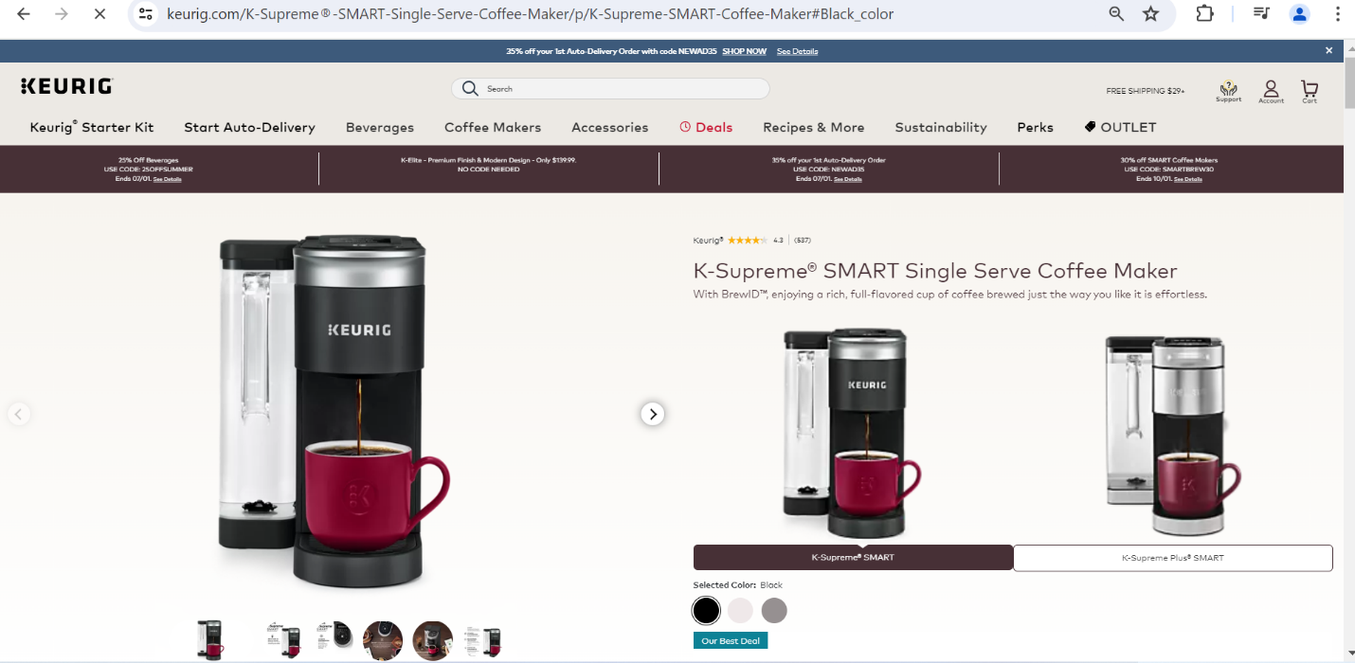

**Fig:3.1.15: PDP Page**

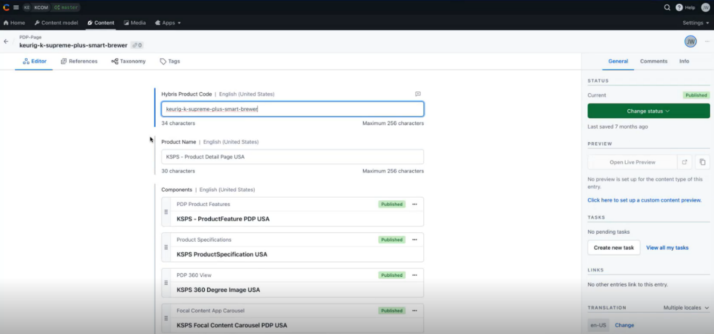

**Fig:3.1.16: PDP Page – Content Entry**

**Landing pages in KCBU**

* 1. Recipe Page
* There is a recipe page where content comes from content hub, The page has all the list of recipes displayed in descending order of date. The recipes are hosted in another space (KCOM), The recipes page has filter option to display the recipes.
* There is view more button to display more recipes up to 180.
* Recipe content is same for Sites and Mobile Apps.

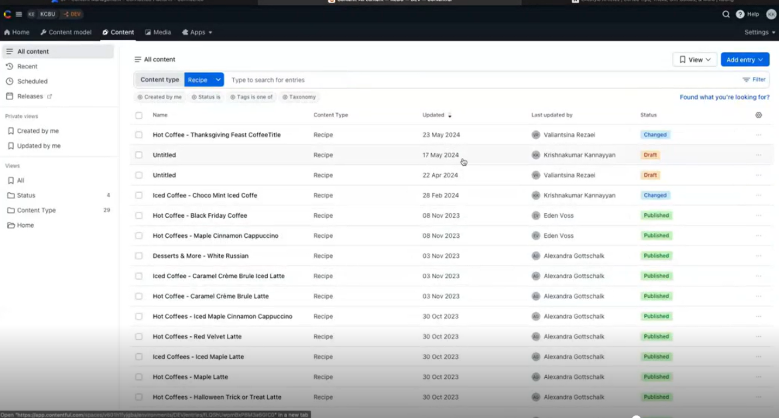

**Fig:3.1.17: Recipes List– Content Type**

**Recipe Template:**

* All the recipes content comes from Recipes Template from Contentful
* Fields: Internal Name, Title, Image to display in recipe navigation, image to display in recipe detail page, Highlights, Matching Pods, ingredients, Preparation sub-title, Preparation steps, Related recipes, Sub Category, Applicable brewer models, Authenticated users, SEO Metadata
* There are sub-templates under Recipe: Recipe>Highlight, Recipe>Ingredient, Recipe>Preparation Step, Recipe>Preparation Steps

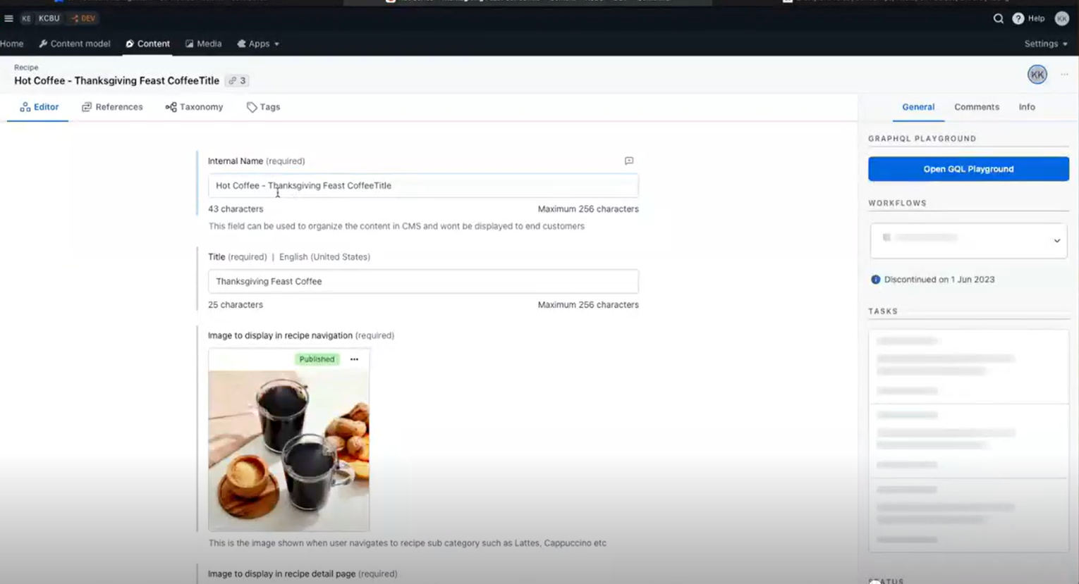

**Fig:3.1.18: Recipes Details– Content Entry**

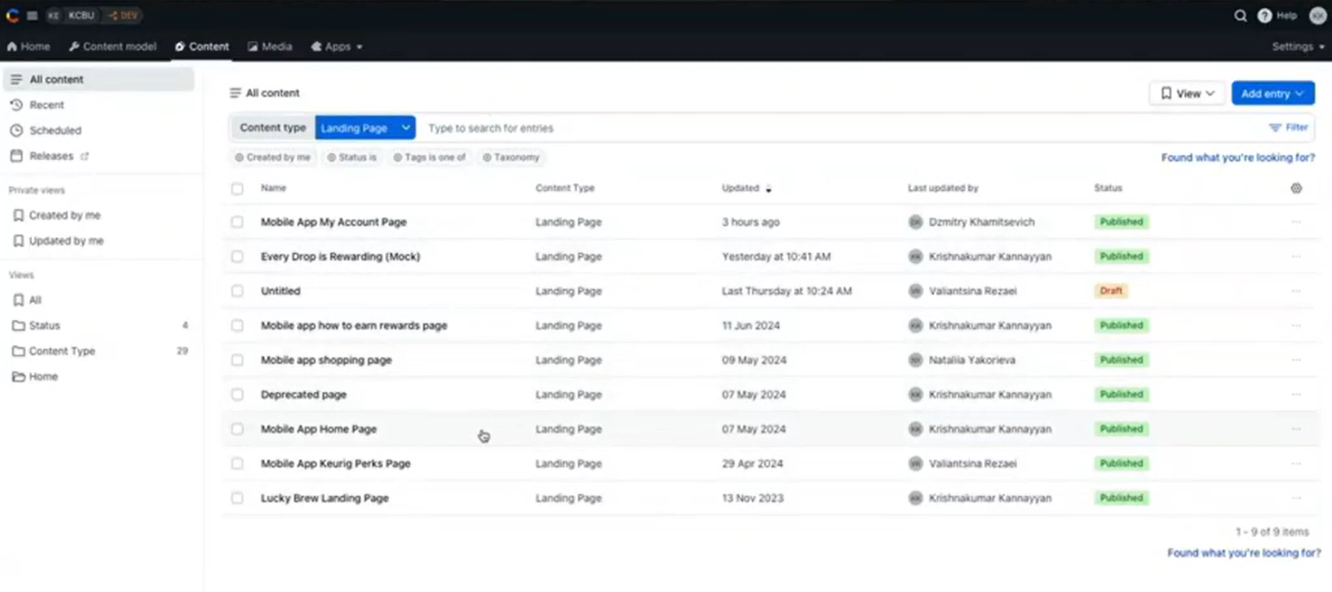

**Fig:3.1.19: Landing Pages List– Content Model**

* Under this landing page we have many important pages such as Lucky brew landing page, Mobile App Home Page, Mobile App Keurig Perks Page and many more.
  1. Mobile App Home Page
* There are many landing pages required by mobile app including home page, Keurig perks page, Lucky brew page

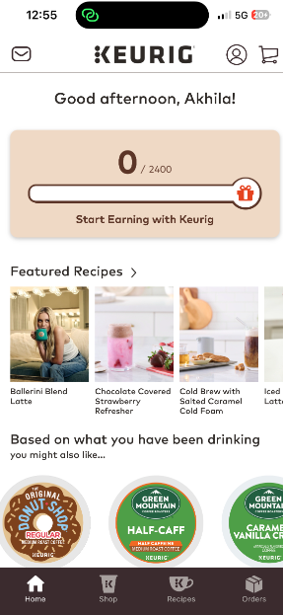

**Fig:3.1.20: Mobile App Home Page**

**Mobile App Home Page Template:**

* Fields: Internal Name, Banner, Content (list of contents)
* Tags

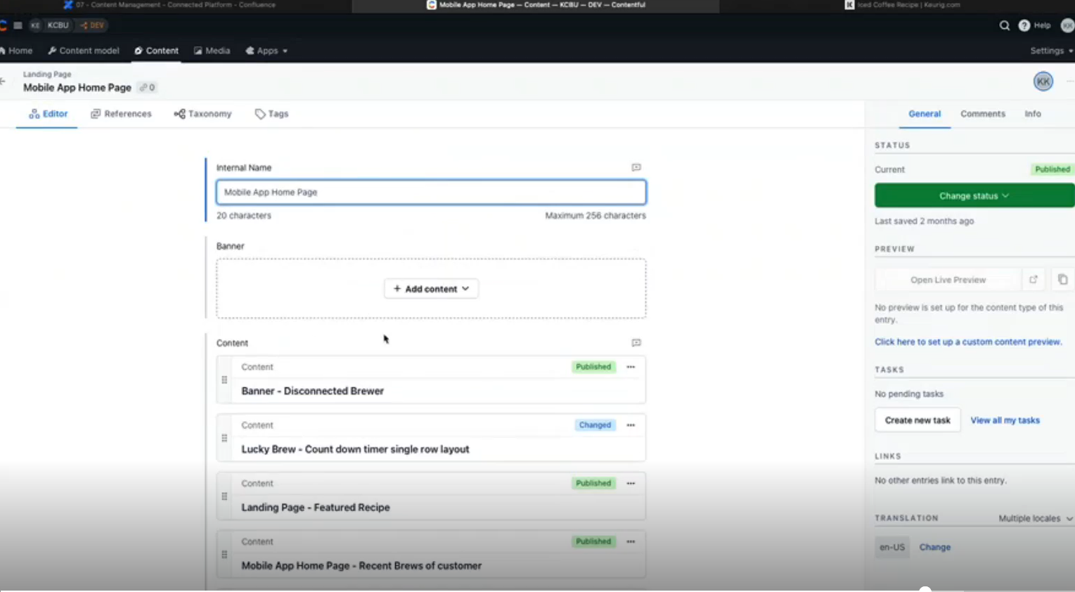

**Fig:3.1.21: Mobile App Home Page – Content Entry**

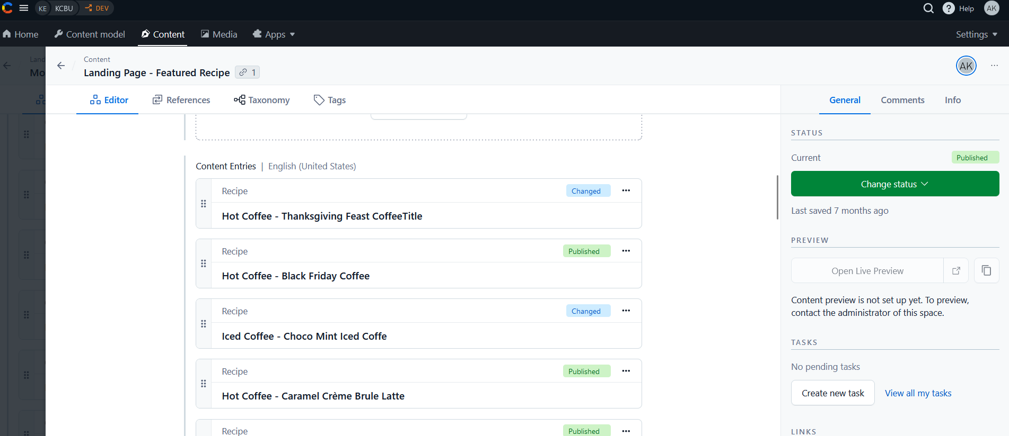 **Fig:3.1.22: Feature Recipe Landing Page – Content Entry**

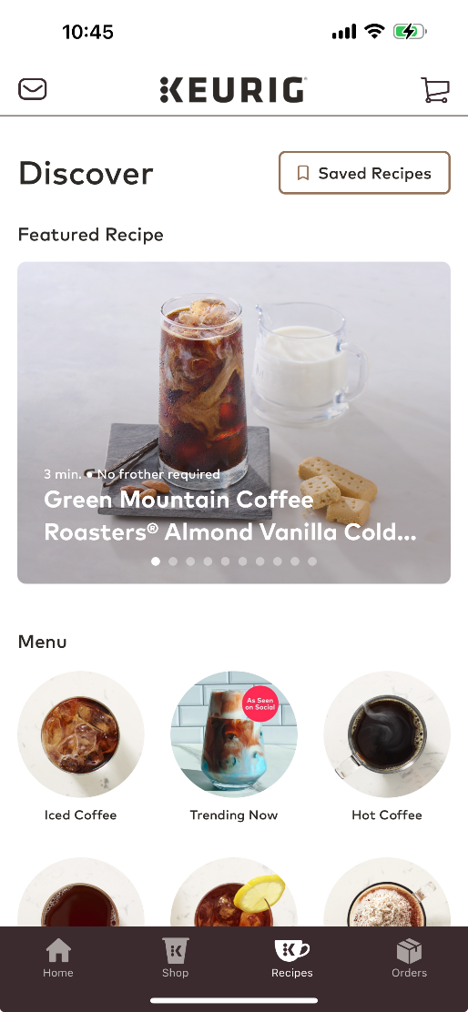  
**Fig:3.1.23: Feature Recipe Landing Page**

**Mobile App Keurig Perks Page Template:**

* Fields: Internal Name, Banner, Content (list of contents)
* The plan is to convert all the mobile app pages with control driven content instead of hard coding the content

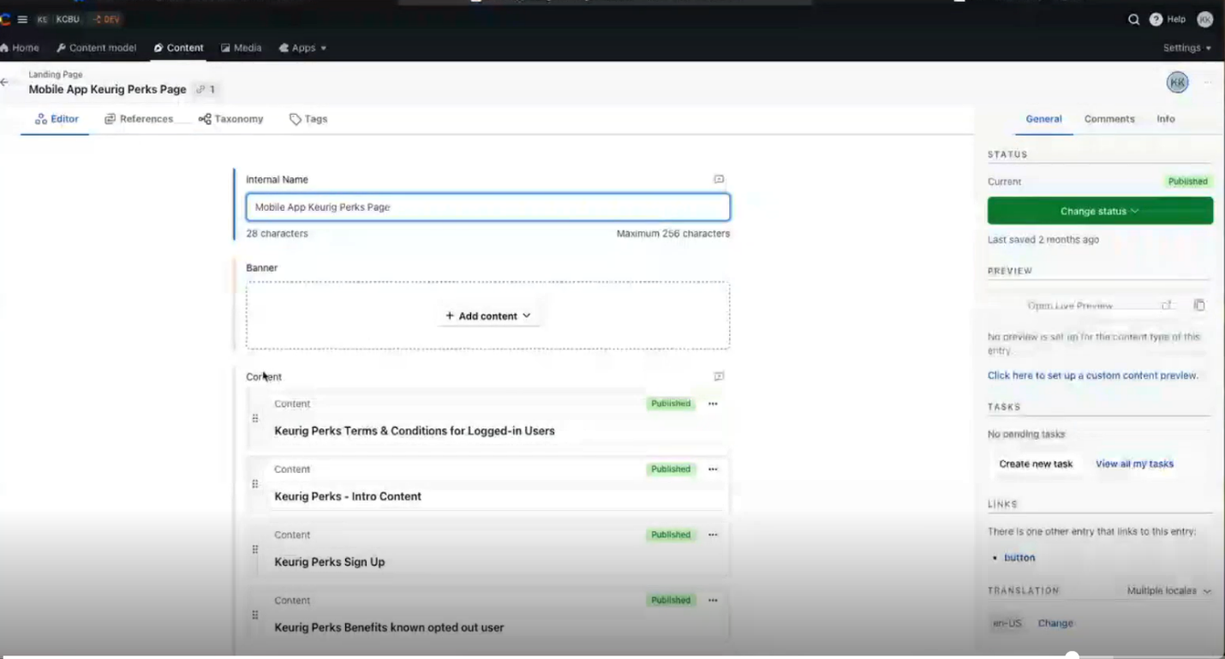

**Fig:3.1.24: Mobile App Keurig Pers Page – Content Entry**

**Lucky Brew Landing page**:

Content related to Keurig perks terms, keurig perks signup and benefitsLucky Brew Landing Page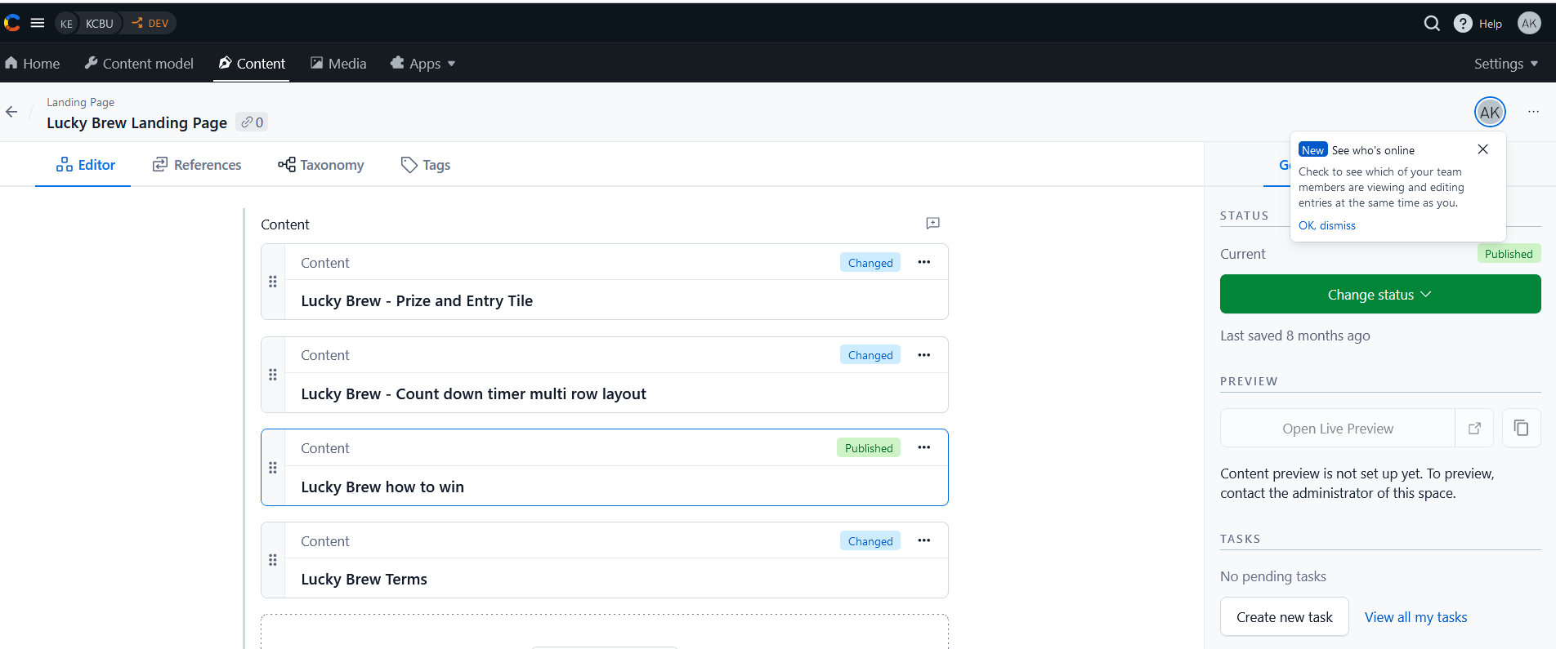

**Fig:3.1.25: Lucky Brew Landing Page – Content Entry**

* Lucky Brew landing page contains all the content about the Lucky brews such as Lucky brew price and Entry title, Terms, how to win it